**PINNACLE 2022 TRAINING**

**DATA STRUCTURES**

**ASSIGNMENT-2**

**NAME:**  VASANTA VANAN R

**ROLL NO:** 201801158

1.Write an algorithm or develop a code to reverse an array in place.

**PROGRAM (PYTHON):**

n = int(input("Enter the limit: "))

li = []

for i in range(n):

s = int(input())

li.append(s)

f = 0

l = n - 1

while(f < l):

li[f], li[l] = li[l], li[f]

f += 1

l -= 1

print(li)

**OUTPUT:**

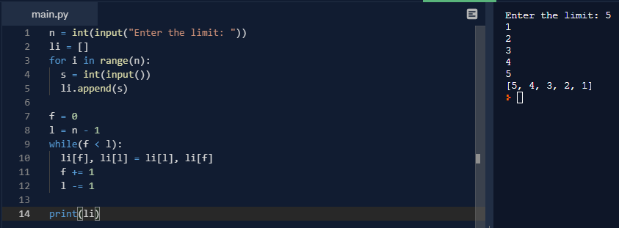

1.Write an algorithm or develop a code to have 2 stacks in 1 array.

**PROGRAM (PYTHON):**

n = int(input("Enter array size: "))

l = []

for i in range(n):

l.append(0)

top1 = int((n / 2))

top2 = int((n / 2) - 1)

while True:

s = int(input("1. Stack 1\n2. Stack 2\n3.Exit\nEnter your option: "))

if(s == 1):

p = int(input("1. Push\n2. Pop\nEnter your option: "))

if(p == 1):

if(top1 == 0):

print("ERROR: Stack Overflow")

else:

e = int(input("Enter the element: "))

top1 -= 1

l[top1] = e

elif(p == 2):

if(top1 >= (n / 2)):

print("ERROR: Stack Underflow")

else:

print("The popped element is: " + str(l[top1]))

top1 += 1

elif(s == 2):

p = int(input("1. Push\n2. Pop\nEnter your option: "))

if(p == 1):

if(top2 == (n - 1)):

print("ERROR: Stack Overflow")

else:

e = int(input("Enter the element: "))

top2 += 1

l[top2] = e

elif(p == 2):

if(top2 <= (n / 2) - 1):

print("ERROR: Stack Underflow")

else:

print("The popped element is: " + str(l[top2]))

top2 -= 1

else:

break

**OUTPUT:**

